**Project Design Phase-II**

**Technology Stack (Architecture & Stack)**

|  |  |
| --- | --- |
| Date | 21 October 2022 |
| Team ID | PNT2022TMID03607 |
| Project Name | Project – Corporate Employee Attrition Analysis |
| Maximum Marks | 4 Marks |

**Technical Architecture:**

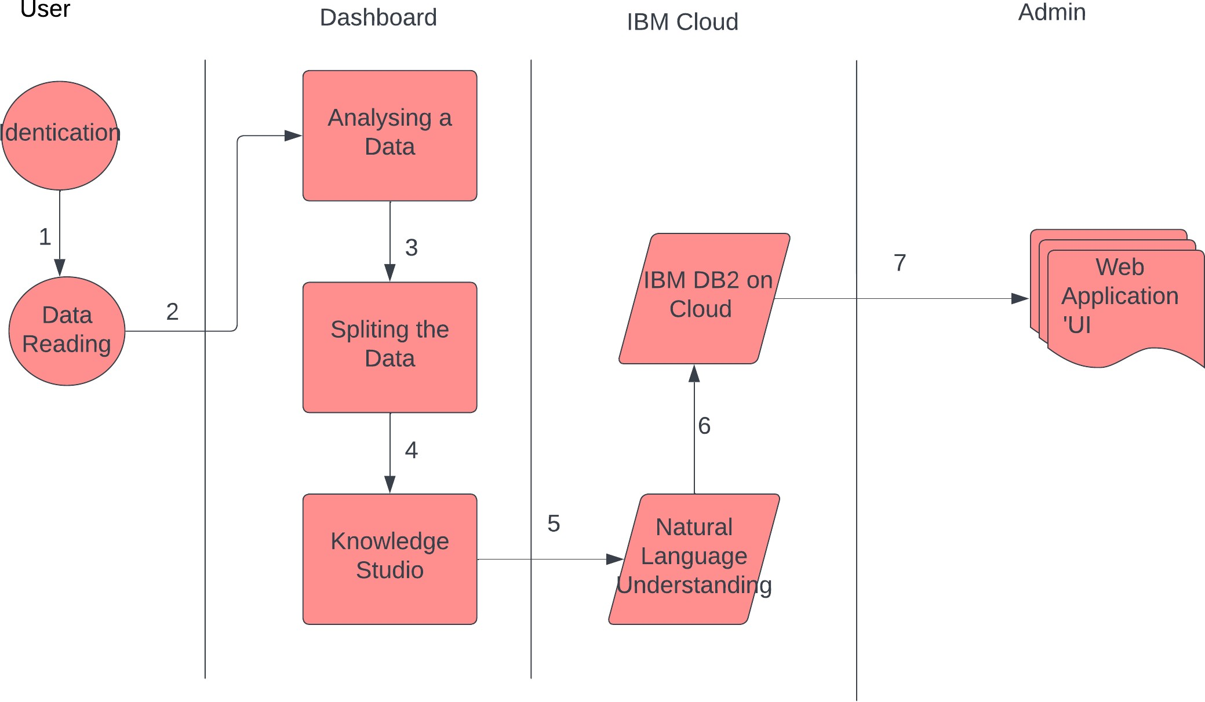

**Table-1 : Components & Technologies:**

|  |  |  |  |
| --- | --- | --- | --- |
| **S No** | **Component** | **Description** | **Technology** |
| 1. | User Interface | How user interacts with application e.g. Web UI, Mobile application | HTML, CSS, JavaScript / Angular Js / React Js etc. |
| 2. | Application Logic-1 | Logic for a process in the application | Java / Python |
| 3. | Application Logic-2 | Logic for a process in the application | IBM Watson STT service |
| 4. | Application Logic-3 | Logic for a process in the application | IBM Watson Assistant |
| 5. | Database | Data Type, Configurations etc. | MySQL, NoSQL, etc. |
| 6. | Cloud Database | Database Service on Cloud | IBM DB2, IBM Cloudant etc. |
| 7. | File Storage | File storage requirements | IBM Block Storage or Other Storage Service or Local Filesystem |
| 8. | External API-1 | Purpose of External API used in the application | IBM Weather API, etc. |
| 9. | External API-2 | Purpose of External API used in the application | Aadhar API, etc. |
| 10. | Machine Learning Model | Purpose of Machine Learning Model | To predict the employee attrition level |
| 11. | Infrastructure (Server / Cloud) | Application Deployment on Local System / Cloud  Local Server Configuration:  Cloud Server Configuration : | Local, Cloud Foundry, Kubernetes, etc. |

**Table-2: Application Characteristics:**

|  |  |  |  |
| --- | --- | --- | --- |
| **S No** | **Characteristics** | **Description** | **Technology** |
| 1. | Open-Source Frameworks | Visualization Dashboard | Python and IBM Cognos |
| 2. | Security Implementations | Access permissions for the particular system information may only be changed by the system’s data administrator. The user’s data must be having an high security measures. | Encryption , Information verification and Face identification |
| 3. | Scalable Architecture | The website attendance limit must be scalable enough to support 200,000 users at a time. The dashboard is scalable for the companies when their employee’s dataset is used for analysis. The model can successfully predict the futuristic approach and suggests preventive measures. | Front end languages , database and backend process |
| 4. | Availability | New module deployment mustn’t impact front page, dashboard and check out pages availability and mustn’t take longer than one hour. The rest of the pages that may experience problems must display a notification with a timer showing when the system is going to be up again. | Encryption, Machine Learning  Algorithm and Natural Language  Process |
| 5. | Performance | The performance of the dashboard is flexible to every user’s. The front-page load time must be no more than 2 seconds for users that access the website using an LTE mobile connection. | Content delivery Network |